Business Language Layer (BLL): A Business-Centric Layer for Explainable Artificial Intelligence
Oyeleke Olayemi Seun¹,* James Wandiya² Cecilia Eze¹ Ocheme Charisa¹ Emmanuel Tomiwa Agboola¹
¹ DataLab Technology Limited, Abuja, Nigeria
² African Institute for Mathematical Sciences (AIMS Senegal), Mbour, Senegal
* Corresponding author: Oyeleke Olayemi Seun, Senior Data Scientist, DataLab Technology Limited, Abuja, Nigeria. Email: o.oyeleke@datalabanalyticshub.com
Abstract
Organizations increasingly depend on artificial intelligence (AI) to support decision-making under conditions of complexity and uncertainty. Yet most AI-assisted decision support systems stop at prediction, relying on post hoc explainability techniques such as SHAP and LIME to answer only the question of why a model produced a given output. These techniques improve transparency by attributing predictions to input features, but they remain model-centric: they do not communicate the business implications, operational consequences, financial impact, or recommended actions that a prediction entails. The result is a translation gap in which decision-makers must rely on data scientists or analysts to convert model outputs into actionable business decisions, delaying decisions and limiting the practical value of AI. This paper introduces the Business Language Layer (BLL), an interactive assisted-explainability reasoning layer that consumes the outputs of existing explainability methods and re-expresses them as business intelligence. Rather than replacing SHAP or LIME, the BLL extends them, advancing the explanation from why the model predicted this to what it means for the business, what outcome to expect, and what to do next. The layer operates through four functions—interpret, contextualise, quantify, and recommend—and is delivered directly within the user interface of a prediction system through comparative reasoning, scenario simulation, impact analysis, and domain-specific recommendations that support fairness, transparency, and trust. We demonstrate the framework through an e-commerce logistics case study in which a late-delivery risk prediction is translated into a monetised, actionable decision brief. The demonstration shows how the BLL converts a technically faithful but operationally silent explanation into guidance an operations lead can act on within seconds. Although demonstrated in logistics, the architecture is domain-agnostic and applicable across finance, healthcare, energy, manufacturing, the public sector, and other high-stakes domains. The BLL reframes explainability from model interpretation toward human-relatable decision intelligence, making Explainable AI more understandable, actionable, and trustworthy for the people who must act on it.
Keywords: Explainable Artificial Intelligence (XAI); Business Language Layer; decision support systems; human-centred AI; SHAP; LIME; actionable explanations; decision intelligence.

1. Introduction
Today's business environment is characterized by increasing complexity and uncertainty, driven by demand fluctuations, supplier disruptions, inventory variability, logistics constraints, changing customer expectations, labour shortages, regulatory changes, pandemics, climate-related events, and broader economic and environmental shocks. These challenges continually influence operational performance and strategic decision-making across industries. To remain competitive in such a dynamic landscape, organizations are increasingly adopting Artificial Intelligence (AI) to support data-driven decision-making across a wide range of business functions.
However, most AI-assisted decision support systems primarily generate predictive outputs and rely on post hoc explainability techniques, such as SHAP and LIME, to answer the question: “Why did the model make this prediction?” These methods explain predictions by quantifying the contribution of individual input features, thereby improving model transparency and interpretability. Despite their value, they remain largely model-centric, focusing on feature attribution rather than business understanding. Consequently, they do not explicitly communicate the business implications, operational consequences, financial impact, or recommended actions associated with a prediction, leaving decision-makers to perform additional interpretation before meaningful business decisions can be made.
In other words, most post hoc Explainable AI (XAI) methods do not communicate model explanations in the language of business. Although they faithfully describe the factors influencing a prediction, they do not directly convey the business implications, expected outcomes, financial consequences, or recommended actions. This translation gap makes it difficult for decision-makers to rapidly convert AI predictions into informed and actionable business decisions. Consequently, decision-makers frequently rely on data scientists, business analysts, or data analysts to translate model outputs into actionable business information, introducing delays in decision-making and limiting the speed, practical usefulness, and interpretability of AI systems.
To address this gap, we propose and prototype an interactive assisted-explainability layer, referred to as the Business Language Layer (BLL), which translates technical machine learning predictions and XAI outputs into business consequences, contextual reasoning, and actionable recommendations. Rather than stopping at “Why did the model make this prediction?”, the proposed layer extends AI explanations by answering higher-level business questions such as: “What does this prediction mean for the business?”, “Who or what is likely to be affected?”, “What are the operational, financial, or customer implications?”, and “What should the business do next?” This represents a shift from model interpretability toward human-relatable decision intelligence.
The Business Language Layer sits above existing XAI techniques and consumes their explanations as inputs before re-expressing them as business intelligence that decision-makers can immediately understand and act upon.
In doing so, it shortens the journey from model output to actionable business insight. In this paper, we demonstrate the assisted-explainability layer as a multi-layered reasoning framework integrated directly into the user interface of machine learning prediction systems. The framework reinterprets XAI metrics into business-facing insights through comparative reasoning, scenario simulation, impact analysis, cost implications, operational burdens, and domain-specific recommendations that support fairness, transparency, and trustworthy AI. By bridging the gap between technical explanations and business understanding, the proposed Business Language Layer makes Explainable AI more relatable, actionable, and valuable to end users, thereby enhancing both decision-making and confidence in AI-assisted systems.

1.1. Contributions
This paper makes the following contributions:
- A business-centric reframing of explainability. We articulate the translation gap between model-centric XAI and business decision-making, and position explainability as a decision-support problem rather than a purely technical one.
- The Business Language Layer (BLL). We propose an interactive assisted-explainability reasoning layer that consumes conventional XAI outputs and re-expresses them as business intelligence through four functions: interpret, contextualise, quantify, and recommend.
- An interface-level demonstration. We instantiate the layer as a live decision surface and demonstrate it through an e-commerce logistics case study, showing how a late-delivery risk prediction becomes a monetised, actionable decision brief.
- A domain-agnostic architecture. We show that the layer generalises beyond logistics to other high-stakes domains, and we characterise its benefits together with how each could be measured.

2. Background and Related Work
The design of the proposed Business Language Layer is informed by established principles in interactive Explainable AI (XAI) interface design. Specifically, we build upon the Interactive Explainable Artificial Intelligence Interface (IXAII) framework proposed by Wang et al. (2019) and extended by Speckmann et al. (2025), which recommends that AI systems should support multiple forms of explanation—including What, Why, How, Why Not, What If, and When—to accommodate different user information needs during decision-making. Table 1 summarises the explanation methods recommended by Speckmann et al. (2025). While these explanation types improve users’ understanding of how AI systems arrive at predictions, our work extends this paradigm by introducing a Business Language Layer that contextualises these explanations in terms of business consequences. In doing so, we shift the focus from explaining how the model thinks to communicating what the prediction means for the business and what actions should follow.
Table 1. Explanation Methods in the Interactive Explainable Artificial Intelligence Interface (IXAII)
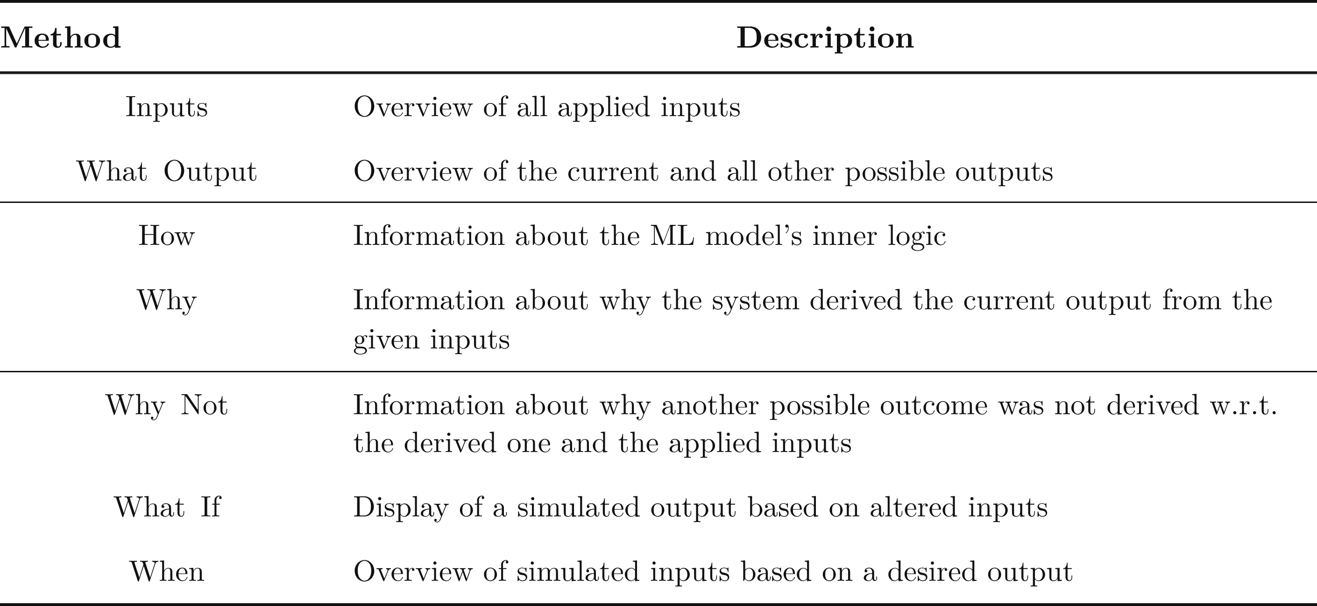
Note. Adapted from IXAII: An Interactive Explainable Artificial Intelligence Interface for Decision Support Systems (Speckmann, Nadj, & Janiesch, 2025).
The proposed Business Language Layer (BLL) builds upon and enriches the capabilities of the explainability methods summarized in Table 1 by contextualising technical model explanations in terms of their business implications and operational consequences. Rather than replacing existing XAI techniques, the BLL serves as an assisted-explainability reasoning layer that translates model-centric explanations into business-oriented decision intelligence. Although the framework is demonstrated within the context of e-commerce logistics, its architecture is domain-agnostic and can be readily integrated into AI-assisted decision support systems across finance, healthcare, education, energy, manufacturing, the public sector, and other high-stakes application domains.

2.1. Reasoning Layers for Decision Support Across Domains
Existing research demonstrates the value of incorporating reasoning layers that extend beyond conventional feature-attribution explanations to support practical decision-making. For example, Wang et al. (2019) developed an explainable AI-driven medical diagnosis system for intensive care phenotyping that presents model outputs through multiple complementary explanation layers (Figure 1). The System Predicted Risk panel communicates the model’s predicted probability for each phenotype, providing the primary prediction (what the model predicts). The Influence of Vital panel complements this with local feature-attribution explanations, similar to SHAP, illustrating how individual physiological variables contribute to the prediction (why the prediction was made). Most importantly, the Counterfactual Rule panel extends beyond explanation by identifying the minimum changes required to alter the prediction—for example, increasing systolic blood pressure above a specified threshold to change a shock prediction. This additional reasoning layer transforms technical explanations into clinically meaningful intervention guidance, enabling healthcare professionals to move from understanding a prediction to determining an appropriate course of action.
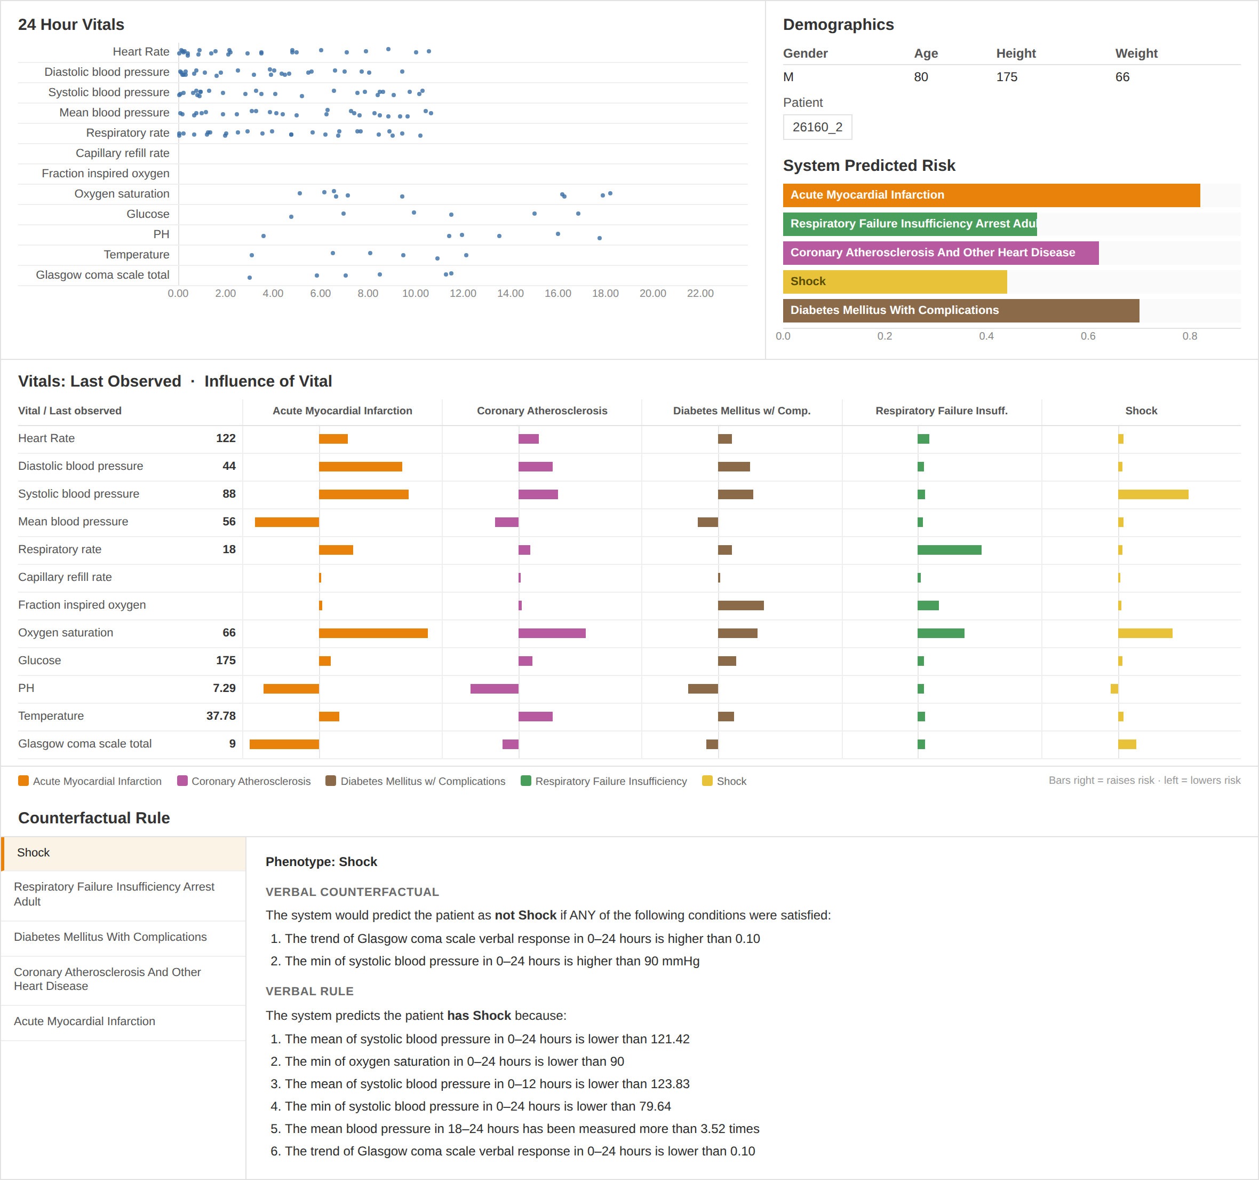
Figure 1. AI-Driven Clinical Decision Support Dashboard for Intensive Care Phenotyping
Note. Adapted from “Designing Theory-Driven User-Centric Explainable AI,” by D. Wang, Q. Yang, A. Abdul, & B. Y. Lim, 2019, Proceedings of the 2019 CHI Conference on Human Factors in Computing Systems (pp. 1–15). Copyright 2019 by the Association for Computing Machinery.
This work provides evidence that effective AI-assisted decision support extends beyond explaining model behaviour alone. Rather, decision-makers benefit from an additional reasoning layer that contextualises technical explanations within domain-specific objectives and translates them into actionable recommendations. This principle aligns closely with the proposed Business Language Layer (BLL). While Wang et al.’s framework is designed specifically for clinical decision support, the BLL generalises this concept by providing a domain-agnostic assisted-explainability reasoning layer that translates conventional XAI outputs into business-oriented intelligence, including operational consequences, financial impact, scenario analysis, comparative reasoning, and recommended actions across diverse application domains.
A second example of assisted-explainability reasoning is demonstrated through a conversational XAI assistant designed to support loan approval decisions (Figure 2). The interface presents explanations through three complementary reasoning layers that progressively enhance decision support. The first panel provides a global explanation, illustrating how loan amount influences creditworthiness across its entire range and enabling users to understand the model’s overall behaviour (how the model generally makes predictions). The second panel presents a local explanation, tracing the decision path through the decision tree that produced the applicant’s specific loan approval outcome (why this particular decision was made). The third panel introduces a counterfactual explanation, identifying the minimum changes to the applicant’s profile that would reverse the prediction, thereby answering why not and what if questions while providing practical recourse for future applications. This example further demonstrates that effective AI-assisted decision support extends beyond conventional model explanations by incorporating reasoning mechanisms that help users interpret predictions within the context of real-world decisions.
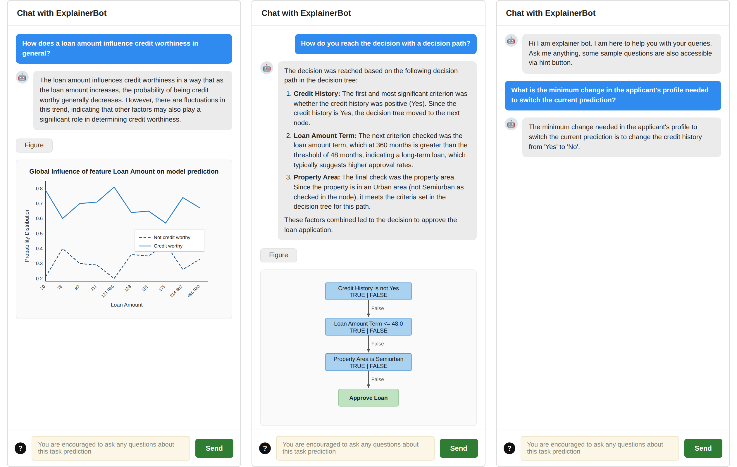
Figure 2. Loan Approval Task via a Conversational XAI Assistant
Note. Adapted from “Is Conversational XAI All You Need? Human-AI Decision Making With a Conversational XAI Assistant,” by G. He, N. Aishwarya, and U. Gadiraju, 2025, Proceedings of the 30th International Conference on Intelligent User Interfaces (pp. 907–924). Copyright 2025 by the Association for Computing Machinery.

3. The Business Language Layer
This section introduces the Business Language Layer (BLL) and the problem it is designed to solve. We first characterise the translation gap that motivates the layer (Figure 3), then present the layer’s architecture and its four functions (Figure 4). The conceptual framework and Business Language Layer presented in the following figures are original contributions of the authors. AI-assisted design tools were used solely to produce the visual layout, annotations, icons, and graphical rendering, all of which were reviewed and refined by the authors.

3.1. The Translation Gap
Conventional XAI output is faithful to the model but is expressed in a technical register that does not answer the questions a decision-maker actually holds. Figure 3 contrasts what an explainer returns—feature-attribution scores for a late-delivery prediction—with the operational, financial, and action-oriented questions a business user needs answered. The explanation is correct, yet none of its individual attributions tell the user whether to ship the order, what it will cost, or which order to prioritise. This is the gap the Business Language Layer is designed to close.
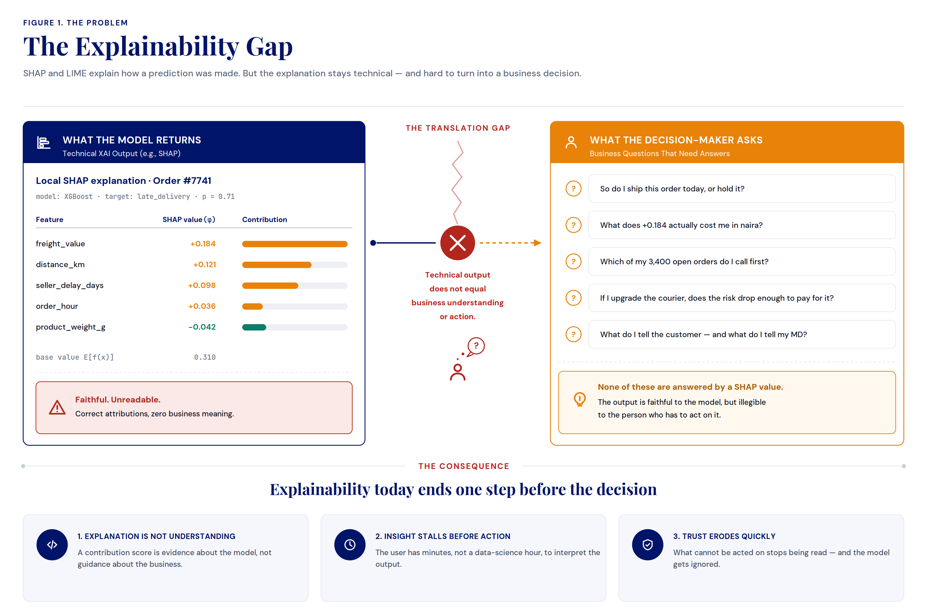
Figure 3. The Explainability Gap
Note. The figure highlights the disconnect between what existing XAI methods explain and what decision-makers need to know. Technical explanations faithfully describe the factors influencing a prediction, whereas business users seek answers about operational impact, financial consequences, risk, and recommended actions. This translation gap means that explainability often stops at model interpretation rather than supporting informed business decisions, motivating the need for a Business Language Layer.

3.2. Architecture and Core Functions
The BLL sits on top of an existing model and its explainer, leaving both untouched, and consumes the explanation they produce. As shown in Figure 4, it re-expresses that explanation as business intelligence through four sequential functions—interpret, contextualise, quantify, and recommend—carrying a single prediction from raw model output through to a decision and its outcome. Because the layer reads the explanation rather than the model, it introduces no retraining and no second predictive model; it is a presentation and reasoning layer, not a competing predictor.
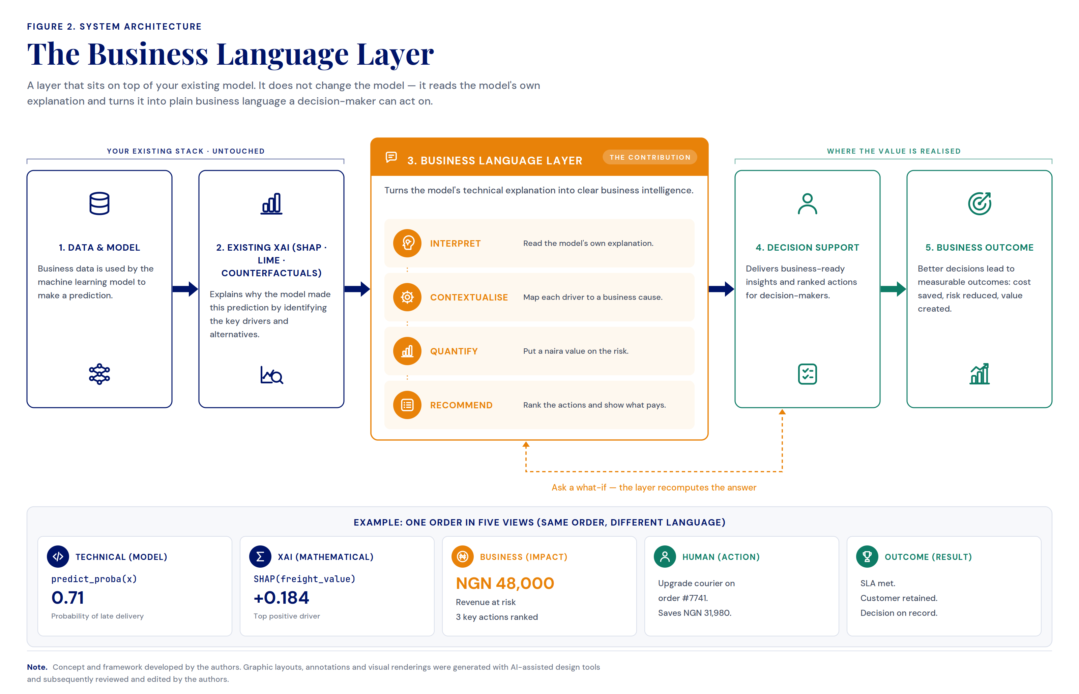
Figure 4. The Business Language Layer
Note. The figure presents the architecture of the Business Language Layer and its place within an existing analytics pipeline. The layer sits on top of the model and its explainer, leaving both untouched, and reads the explanation they produce. Through four functions—interpret, contextualise, quantify, and recommend—it re-expresses that technical explanation as business intelligence, carrying a single prediction from raw model output through to a decision and its outcome. The example strip shows the same order described in five successive registers, illustrating how meaning is preserved while the language shifts from machine to business.

4. Demonstration: An E-Commerce Logistics Case Study
To demonstrate the practical applicability of the Business Language Layer, we present an e-commerce logistics case study in which a machine learning model predicts the risk that an order will be delivered late. The case study illustrates how the BLL transforms conventional XAI outputs into insights that are more understandable, actionable, and relevant to business decision-makers, thereby bridging the gap between technical model explanations and business reasoning and enhancing user understanding, trust, transparency, and operational decision-making.

4.1. The Layer as a Live Decision Surface
Figure 5 shows the BLL operating as a live decision surface for a single order. The same model output that appears elsewhere as raw contribution scores is here re-expressed as a risk level, a set of plainly worded contributing factors, a monetised business impact, and a single recommended action with its net saving. Each numbered region of the interface corresponds to one of the four layer functions—interpret, contextualise, quantify, and recommend—showing how a technical explanation is progressively translated into a decision an operations lead can act on within seconds.
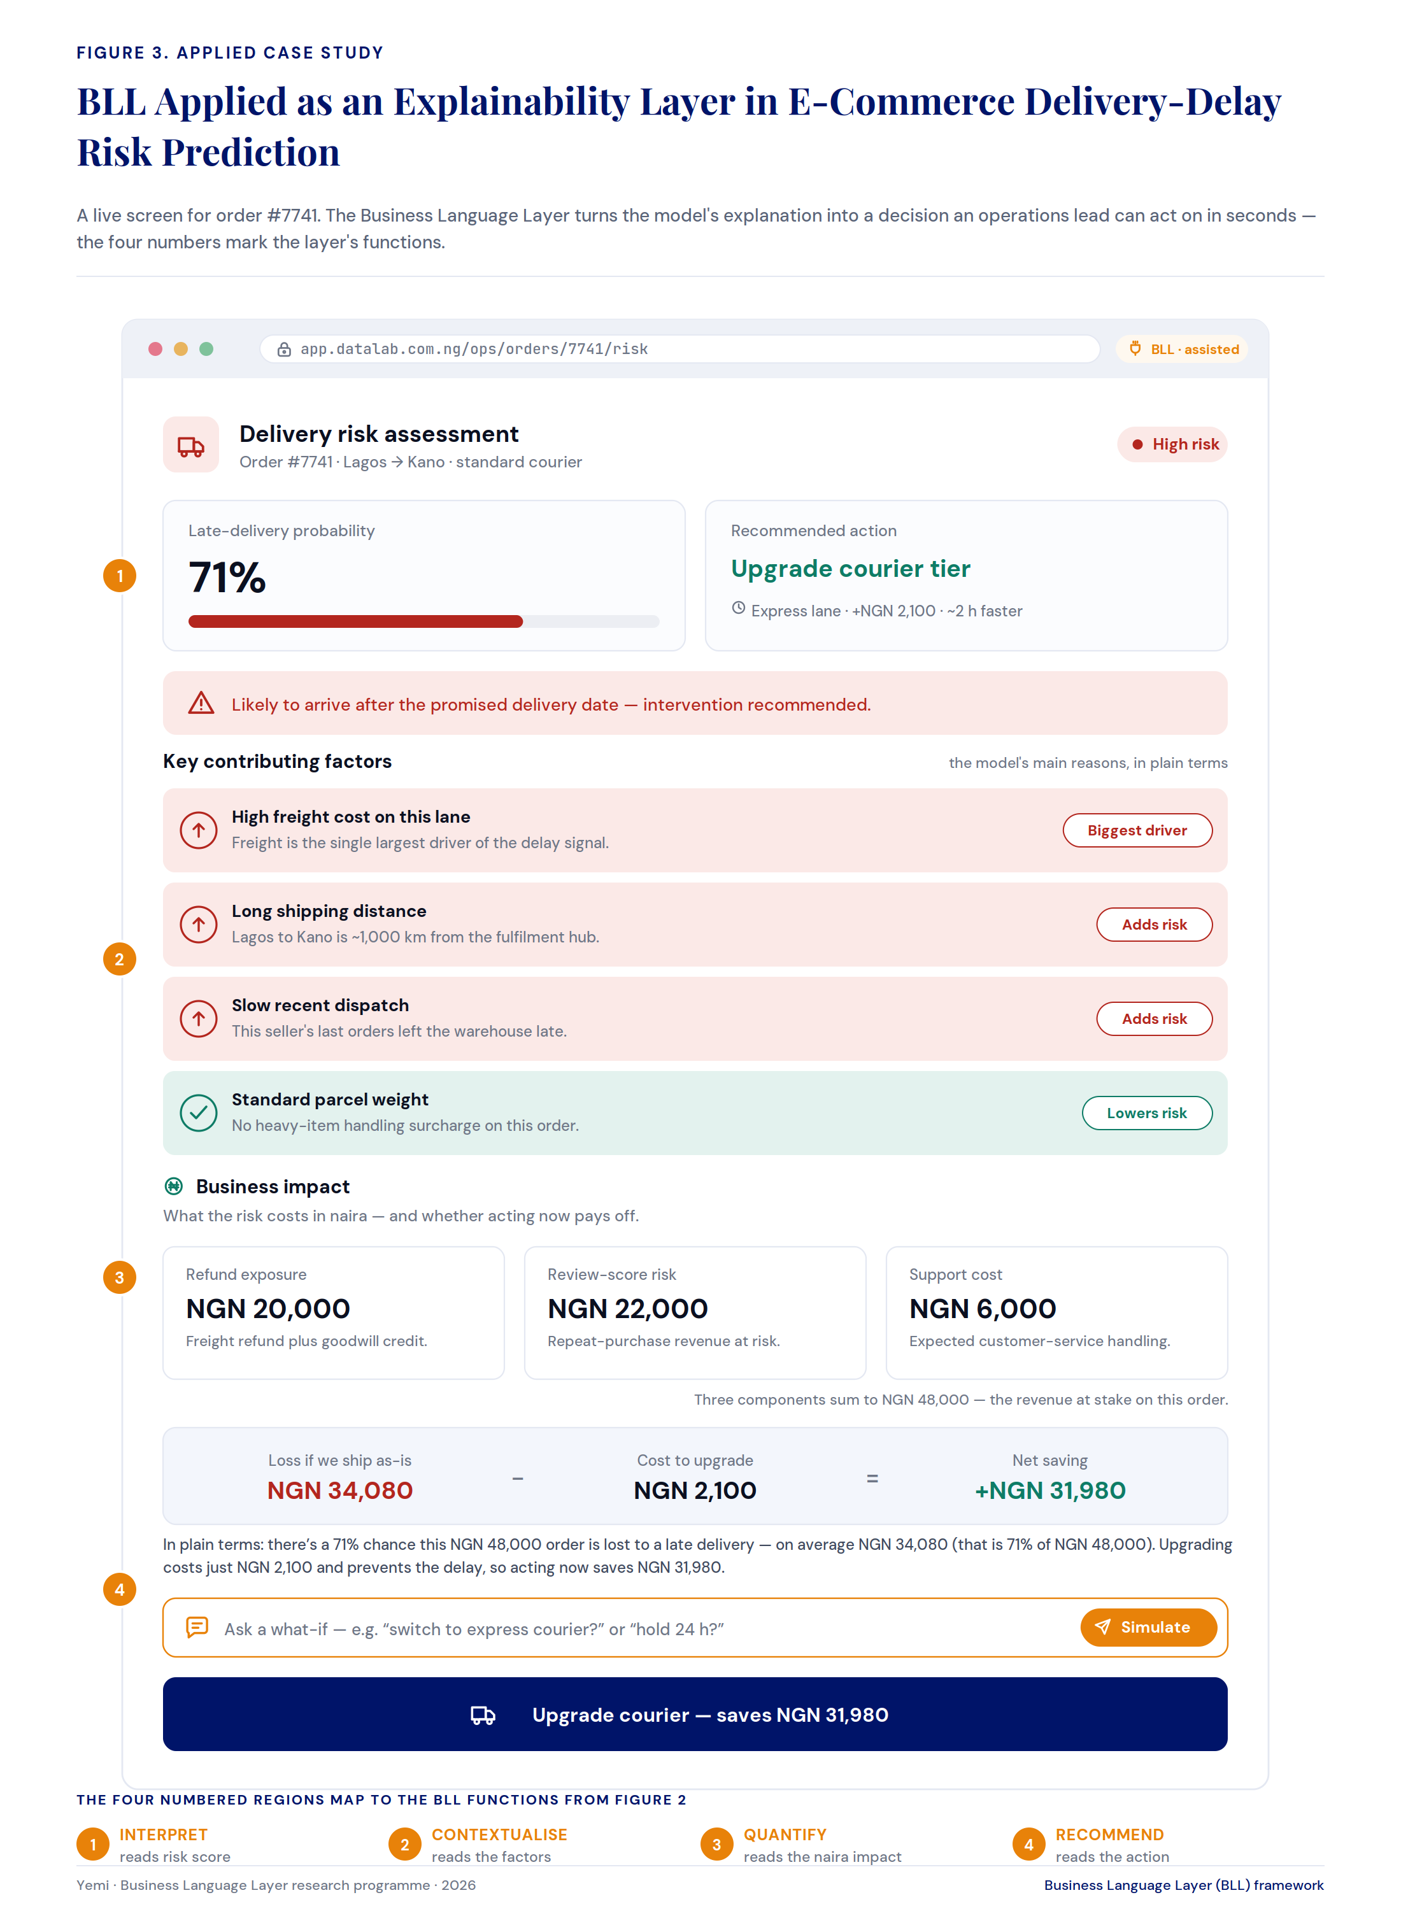
Figure 5. BLL Applied as an Explainability Layer in E-Commerce Delivery-Delay Risk Prediction
Note. The figure demonstrates the Business Language Layer operating as a live decision surface for a single order. The same model output that appears as raw contribution scores elsewhere is here re-expressed as a risk level, a set of plainly worded contributing factors, a monetised business impact, and a single recommended action with its net saving. Each numbered region corresponds to one of the four layer functions—interpret, contextualise, quantify, and recommend—showing how a technical explanation is progressively translated into a decision an operations lead can act on within seconds.

4.2. The Same Evidence, Two Registers
Figure 6 places the technical explanation and the business decision brief side by side. On the left, a technically complete explanation lists the factors behind the late-delivery prediction but offers no guidance on what to do. On the right, the layer converts that identical explanation into a decision brief: a plainly stated recommendation, a set of costed alternatives, and the monetary consequence of each. The evidence is unchanged—only its register, its resolution, and its intended reader differ.
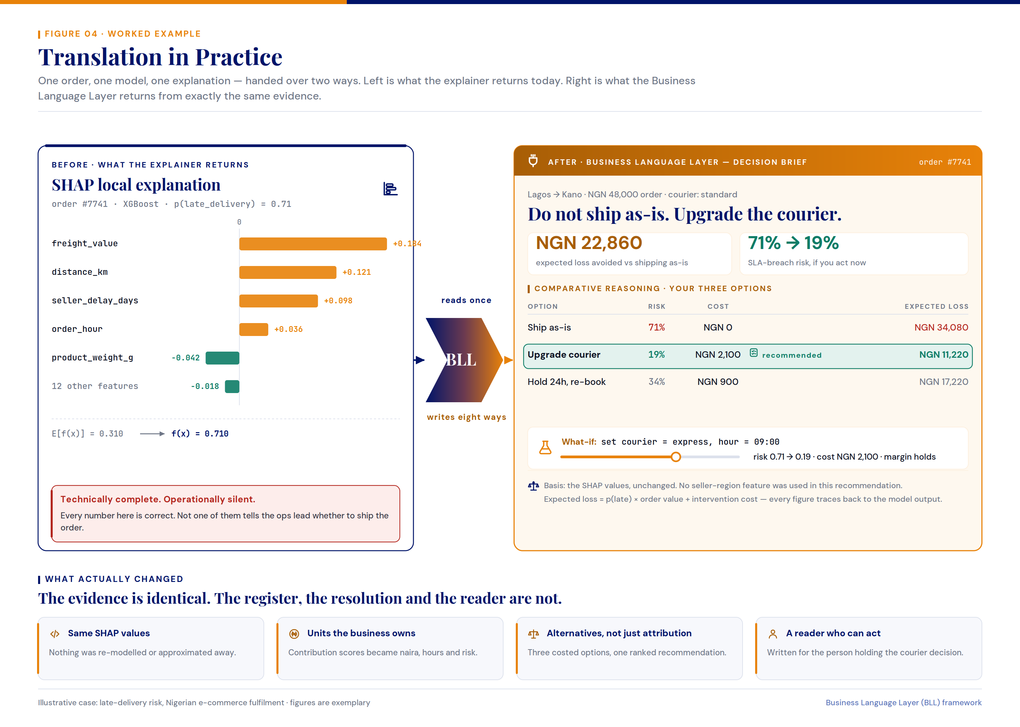
Figure 6. Translation in Practice
Note. The figure contrasts what the explainer returns today with what the Business Language Layer produces from the same evidence. On the left, a technically complete SHAP explanation lists the factors behind a late-delivery prediction but offers no guidance on what to do. On the right, the layer converts that identical explanation into a decision brief: a plainly stated recommendation, a set of costed alternatives, and the monetary consequence of each. The comparison shows that the underlying evidence is unchanged—only its register, its resolution, and its intended reader differ.

4.3. From “Why” to “What Now”
Figure 7 frames explainability as a sequence of questions that a decision requires—why, so what, what then, and what now. Existing XAI methods answer only the first, describing why a model made its prediction. The Business Language Layer supplies the remaining three, translating the same explanation into business meaning, expected outcome, and a costed recommendation. The contribution is therefore positioned not as a correction of SHAP or LIME, but as the layer that carries a faithful explanation the rest of the way to a defensible decision.
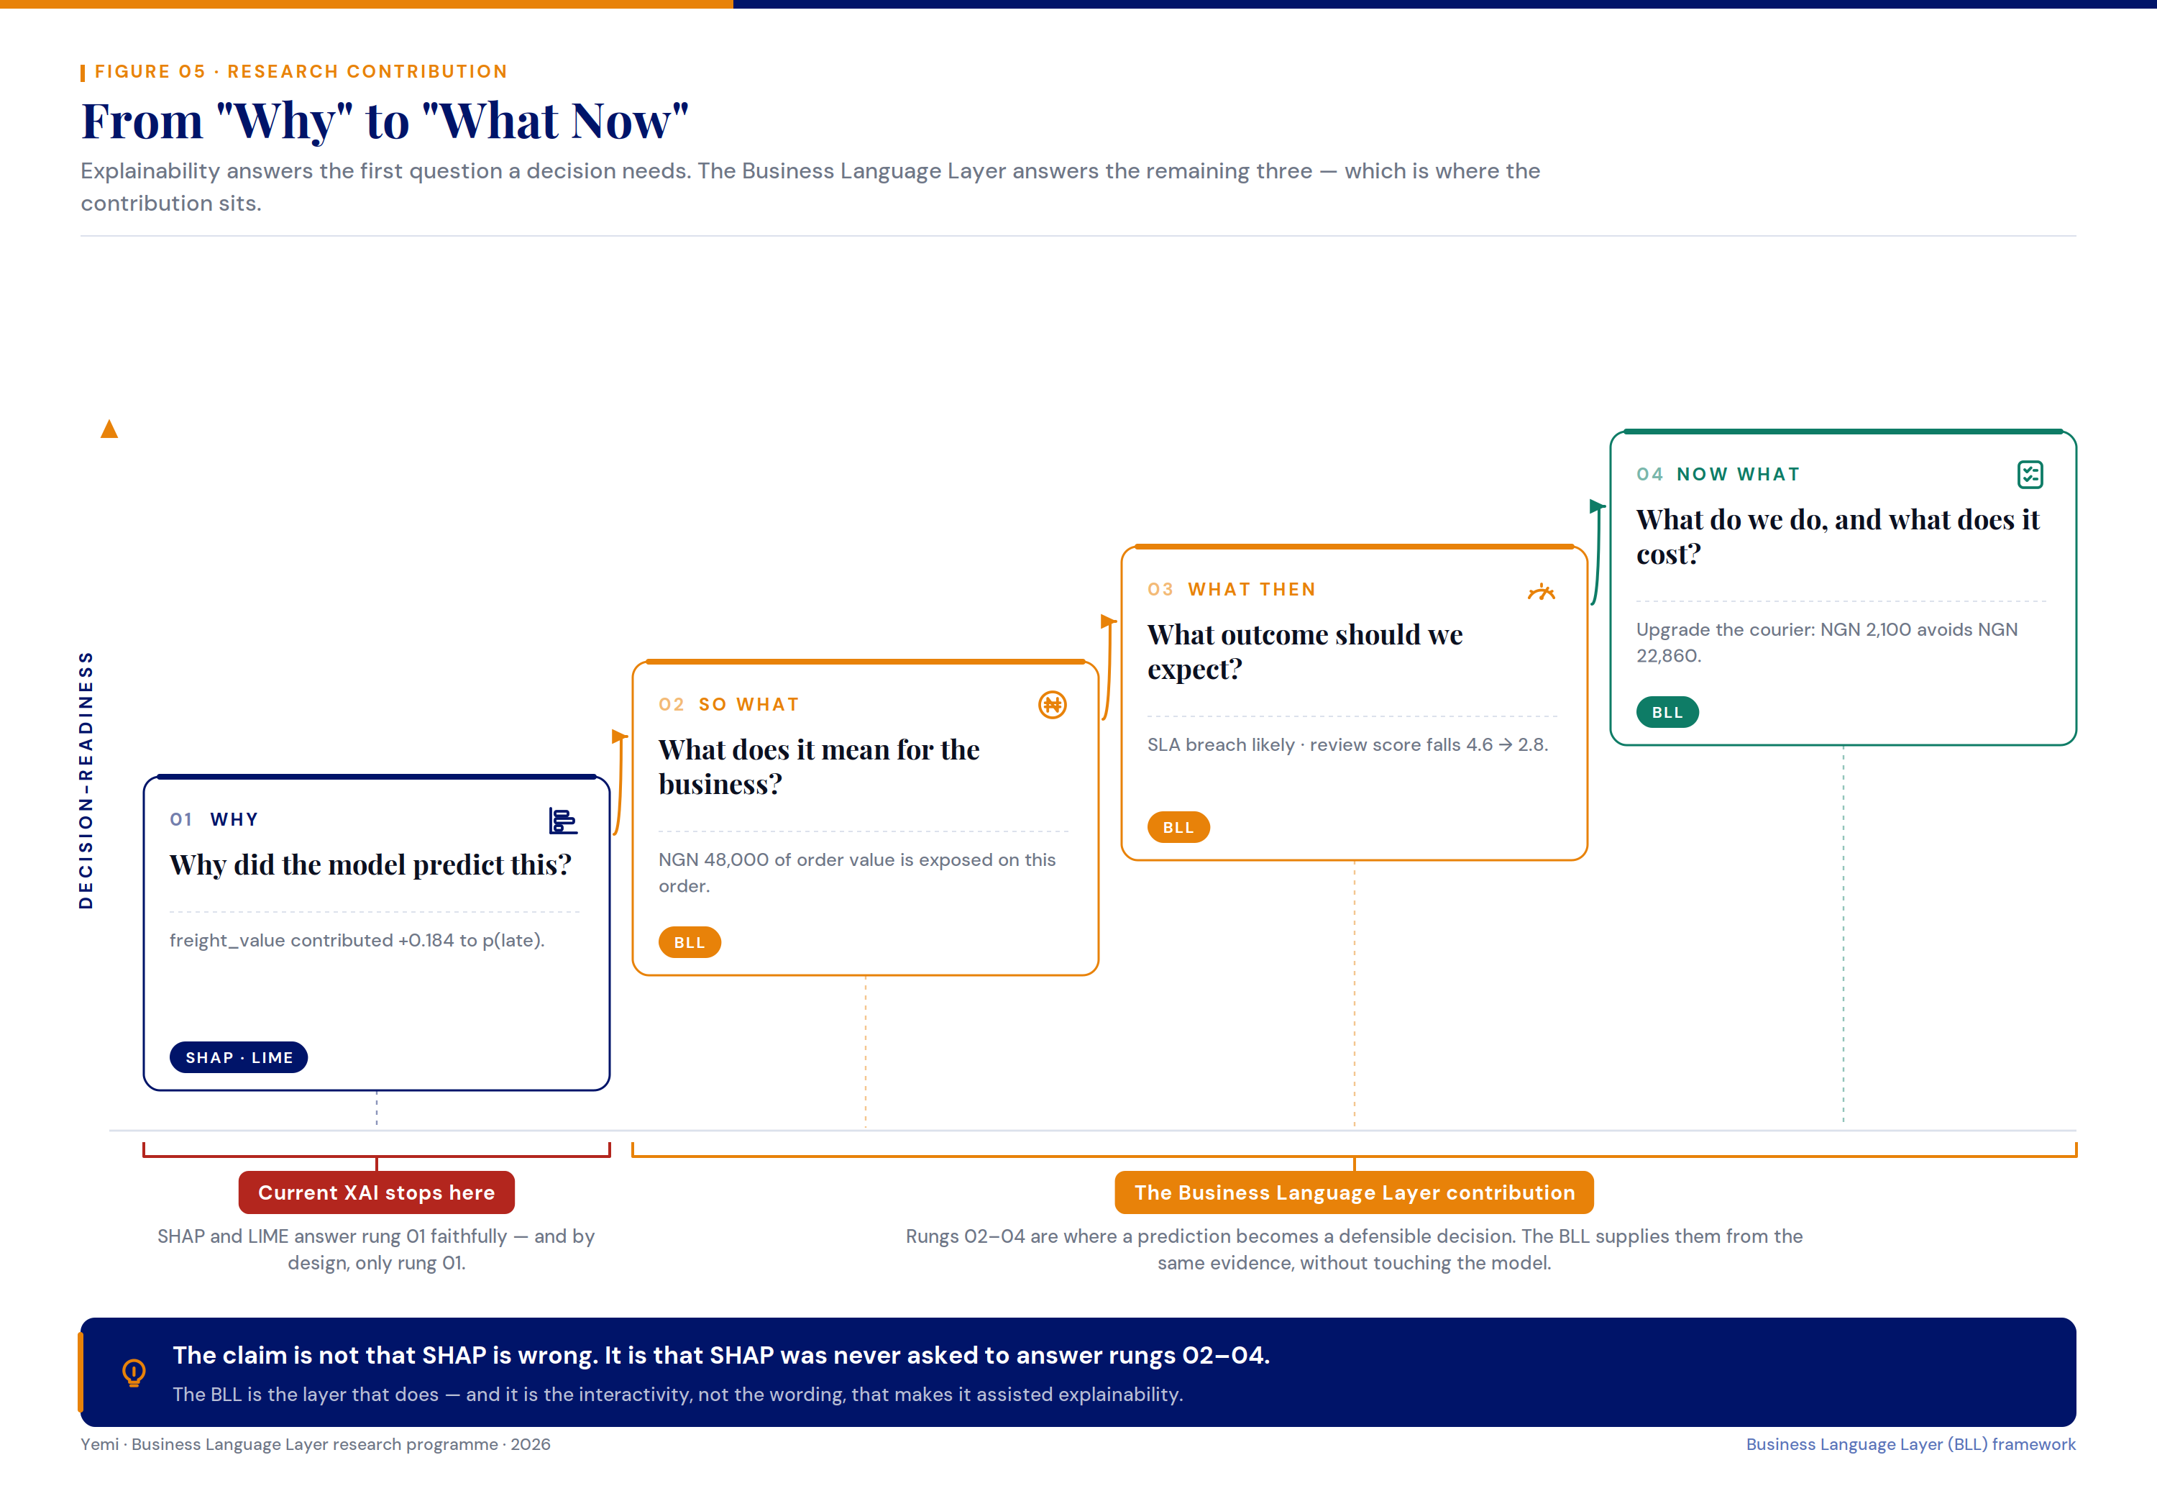
Figure 7. From “Why” to “What Now”
Note. The figure frames explainability as a sequence of questions a decision requires—why, so what, what then, and what now. Existing XAI methods answer only the first, describing why a model made its prediction. The Business Language Layer supplies the remaining three, translating that same explanation into business meaning, expected outcome, and a costed recommendation. The figure positions the contribution not as a correction of SHAP or LIME, but as the layer that carries a faithful explanation the rest of the way to a defensible decision.

5. Benefits and Discussion
Taken together, the demonstration illustrates a set of benefits that follow from re-expressing model explanations in business language. Figure 8 summarises these benefits, grouped by what each one changes for the organisation: what the user understands, what the user can do, and what the organisation can defend. Each benefit is paired with a way it could be measured, indicating that the layer’s value extends beyond comprehension of a single prediction toward decision support and governance.
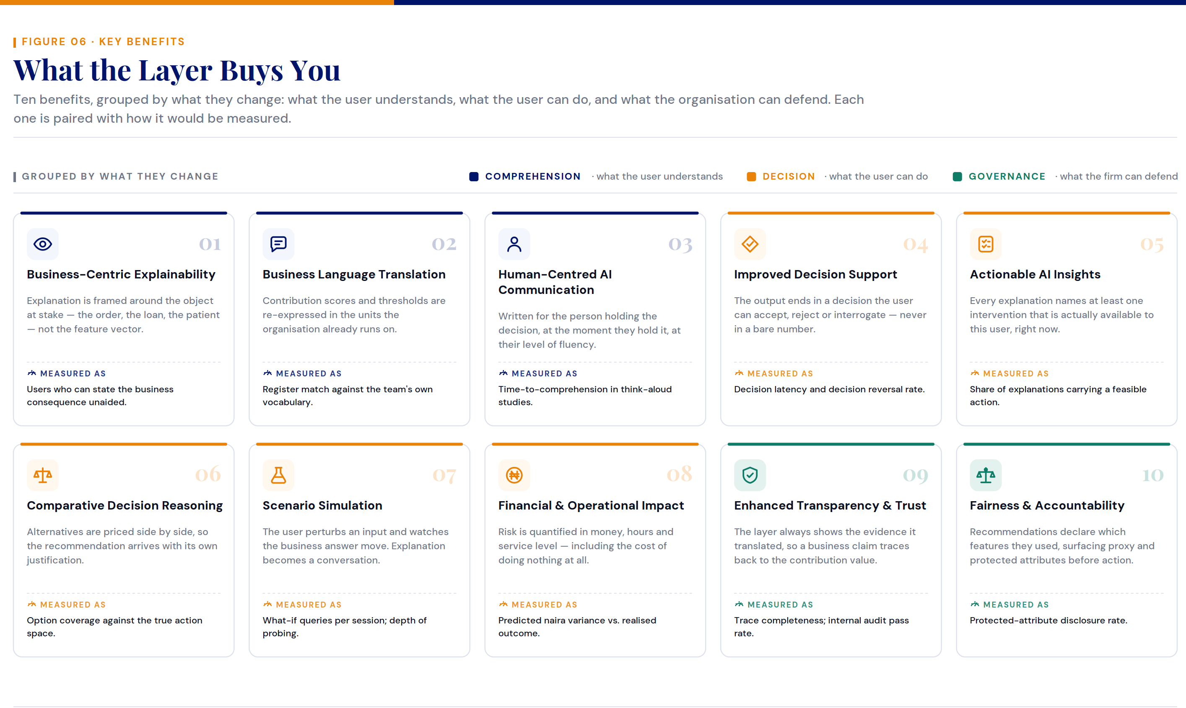
Figure 8. Key Benefits of the Business Language Layer
Note. The figure summarises the main benefits of the Business Language Layer, grouped by what each one changes: what the user understands, what the user can do, and what the organisation can defend. Each benefit is paired with a simple way to measure it, showing that the layer’s value extends beyond understanding a prediction to supporting and accounting for the decisions that follow.
By providing assisted, human-relatable, multi-layered explainability, the BLL accommodates diverse user decision preferences, purposes of use, and decision contexts. This improves the design of effective XAI interfaces, enabling users to weigh options and implications, to identify the strengths and weaknesses of powerful AI models and their outputs, and to reach personalised decisions with greater confidence. In turn, this can reduce scepticism toward, and over-reliance on, AI-assisted decision-making, particularly in high-stakes domains.

6. Limitations and Future Work
This paper introduces and demonstrates the Business Language Layer conceptually and through an interface-level prototype; it does not yet report a controlled empirical evaluation. The demonstration is illustrative, drawn from a single e-commerce logistics scenario, and the figures presented use exemplary values to convey the layer’s behaviour rather than results from a deployed system. Accordingly, the benefits identified in Section 5 are accompanied by proposed measures rather than measured outcomes.
We also note a consideration intrinsic to the approach. Because the layer re-expresses an explanation as a fluent, costed recommendation, its output is inherently more persuasive than a raw attribution score—including in cases where the underlying model is wrong. Calibration, the faithful preservation of the original evidence, and the disclosure of the features used are therefore load-bearing design requirements rather than optional refinements, and they warrant explicit treatment in any deployment.
Future work will pursue three directions. First, controlled user studies across expert and non-expert populations will evaluate the measures proposed in Section 5, including time-to-comprehension, decision latency, and decision quality. Second, we will instantiate the layer in additional high-stakes domains—such as finance, healthcare, and energy—to test the domain-agnostic claim empirically. Third, we will investigate the governance dimension of the layer, including traceability from every business statement back to its originating attribution, and the disclosure of protected or proxy attributes prior to action.

7. Conclusion
This paper introduced the Business Language Layer (BLL), an interactive assisted-explainability reasoning layer that re-expresses the outputs of conventional Explainable AI techniques as business intelligence. The central contribution is conceptual as much as technical: we reframe explainability from a model-centric activity—answering why a prediction was made—into a decision-centric one that also answers what a prediction means for the business, what outcome to expect, and what action to take. In doing so, the BLL addresses a translation gap that has limited the practical value of XAI in operational settings.
Theoretically, the work extends interactive XAI interface design by adding a business-reasoning layer above existing explanation methods, distinguishing the act of explaining how a model thinks from the act of communicating what its prediction means for a decision. Practically, the demonstration shows how a faithful but operationally silent explanation can be converted, within the user interface and without retraining, into a monetised and actionable decision brief that a non-technical decision-maker can act on within seconds. Because the layer reads explanations rather than models, it is domain-agnostic and can be integrated into AI-assisted decision support systems across finance, healthcare, education, energy, manufacturing, and the public sector.
The approach has limitations—principally the absence of a controlled empirical evaluation and the need to guard against the persuasive power of fluent recommendations—which define a clear agenda for future work in empirical evaluation, cross-domain instantiation, and governance. By making Explainable AI more relatable, actionable, and trustworthy for the people who must act on it, the Business Language Layer offers a path from model interpretability toward human-relatable decision intelligence, reducing scepticism and illusion in AI-assisted decision-making in high-stakes domains.

References
He, G., Aishwarya, N., & Gadiraju, U. (2025). Is conversational XAI all you need? Human-AI decision making with a conversational XAI assistant. In Proceedings of the 30th International Conference on Intelligent User Interfaces (pp. 907–924).
Speckmann, P., Nadj, M., & Janiesch, C. (2025). IXAII: An interactive explainable artificial intelligence interface for decision support systems (arXiv preprint arXiv:2506.21310).
Wang, D., Yang, Q., Abdul, A., & Lim, B. Y. (2019). Designing theory-driven user-centric explainable AI. In Proceedings of the 2019 CHI Conference on Human Factors in Computing Systems (pp. 1–15). Association for Computing Machinery. https://doi.org/10.1145/3290605.3300831

Appendix A. Consolidated Figure Set
This appendix consolidates the six original figures that define and demonstrate the Business Language Layer (Figures 3–8 in the main text), reproduced together for reference. The figures share a single worked example—a late-delivery risk assessment in Nigerian e-commerce fulfilment—and a common visual system. Figure layouts, annotations, and visual renderings were generated with AI-assisted design tools and subsequently reviewed and edited by the authors.
Figure A1. The Explainability Gap (main text Figure 3)

Figure A2. The Business Language Layer (main text Figure 4)

Figure A3. BLL Applied in E-Commerce Delivery-Delay Risk Prediction (main text Figure 5)

Figure A4. Translation in Practice (main text Figure 6)

Figure A5. From “Why” to “What Now” (main text Figure 7)

Figure A6. Key Benefits of the Business Language Layer (main text Figure 8)

